**INTERPRETING DOCTOR’S PRESCRIPTION**

*EPICS PROJECT REPORT submitted in partial fulfillment of the requirements Submitted by*

**MOHAMMAD RIZWANULLAH 208W1A1299**

**NAGARAJU AJAY KUMAR VARMA 208W1A12A1**

*Under the Guidance of*

**Dr M.SUNEETHA, Ph.D**

**PROFESSOR AND HEAD**

*For the award of the degree* **BACHELOR OF TECHNOLOGY IN**

#### INFORMATION TECHNOLOGY



**DEPARTMENT OF INFORMATION TECHNOLOGY V R SIDDHARTHA ENGINEERING COLLEGE**

**(AUTONOMOUS - AFFILIATED TO JNTU-K, KAKINADA)**

### Approved by AICTE & Accredited by NBA

#### KANURU, VIJAYAWADA-7 ACADEMIC YEAR

**(2022-23)**

V.R.SIDDHARTHA ENGINEERING COLLEGE

(Affiliated to JNTUK: Kakinada, Approved by AICTE, Autonomous) (An ISO certified and NBA accredited institution)

Kanuru, Vijayawada – 520007



# CERTIFICATE

This is to certify that this project report titled **“INTERPRETING DOCTOR’S PRESCRIPTION”** is a Bonafide record of work done by **MOHAMMAD RIZWANULLAH (208W1A1299)** and **NAGARAJU AJAY KUMAR VARMA(208W1A12A1)** and under my guidance and supervision is submitted in partial fulfillment of the requirements for the award of the degree of Bachelor of Technology in Information Technology, **V.R. Siddhartha Engineering College** (Autonomous under JNTUK) during the year **2022-2023**.

#### (Dr. M.SUNEETHA)

Professor & Head

Dept. of Information Technology

**EXTERNAL EXAMINER**

**PROJECT SUMMARY**

|  |  |  |
| --- | --- | --- |
| S.No | Item | Description |
| 1 | **Project Title** | **INTERPRETING DOCTOR’S PRESCRIPTION** |
| 2 | **Student Names & Numbers** | **MOHAMMAD RIZWANULLAH (208W1A1299)**  **N. AJAY KUMAR VARMA (208W1A12A1)** |
| 3 | **Name of The Guide** | **Dr.M.Suneetha** |
| 4 | **Name of The Mentor** | **Y.Sandeep** |
| 5 | **Research Group** | **AI/ML/DL** |
| 6 | **Application Area** | **Health Care** |
| 7 | **Aim of the Project** | **Recognize Doctor’s Handwriting** |
| 8 | **Project Outcomes** | **Providing the digital text of handwriting** |

**Student Signatures**

1. **Md Rizwanullah**
2. **N Ajay Kumar Varma**

### 

### 

### 

### ACKNOWLEDGEMENT

First and foremost, I sincerely salute our esteemed institution **V.R SIDDHARTHA ENGINEERING COLLEGE** for giving me this opportunity for fulfilling my project. I am grateful to our principal **Dr. A.V.RATNA PRASAD**, for his encouragement and support all through the way of my project.

On the submission of this Project report, I would like to extend my honor to **Dr.M. Suneetha**, Head of the Department, IT for her constant motivation and support during the course of my work.

I feel glad to express my deep sense of gratitude to my project guide **DR.M.Suneetha, Professor and Head** for her guidance and assistance in completing this project successfully.

I would also like to convey my sincere indebtedness to all faculty members, including supporting staff of the Department, friends and family members who bestowed their great effort and guidance at appropriate times without which it would have been very difficult on my part to finish the project work.

|  |  |  |
| --- | --- | --- |
| **TABLE OF CONTENTS** |  |  |
| ACKNOWLEDGEMENT | 3 |  |
| LIST OF FIGURES | 6 |  |
| ABSTRACT | 7 |  |
| **CHAPTER-1 Introduction** | 8 |  |
| 1.1 Origin of the Problem | 9 |  |
| 1.2 Basic definitions and Background | 9 |  |
| 1.3 Problem Statement | 10 |  |
| 1.4 Socetial applications of proposed work | 10 |  |
| **CHAPTER-2 Review of Literature** | 11 |  |
| 2.1 Description of Existing Systems  2.2 Summary of Literature Study | 11 |  |
| **CHAPTER-3 Proposed Method** | 13 |  |
| 3.1 Design Methodology | 13 |  |
| 3.2 System Architecture Diagram | 15 |  |
| 3.2.1 WIFI MODULE | 17 |  |
| 3.2.2 GPS Module | 18 |  |
| 3.2.3 ARDUNIO UNO | 23 |  |
| * + 1. LOAD CELL     2. HX711 AMPLIFIER BOARD     3.3 Description of Algorithms    3.4 Description of datasets,Requirement specification | 25  26 |  |

|  |  |  |
| --- | --- | --- |
|  | |  |
|  |  |  |
|  |  |  |
| **CHAPTER-4 Results and observations** | 35 |  |
| 4.1 Stepwise description of Results | 35 |  |
| 4.2 Test case results/Result Analysis    4.3 Observation from the work | 37 |  |
| **CHAPTER-5 Conclusion and Future Study**  5.1 Conclusion  5.2 Future Study | 38 |  |
|  |  |  |
|  |  |  |

#### REFERENCES 39

**LIST OF FIGURES**

|  |  |
| --- | --- |
| **Figure** | **Page** |
| Fig-3.1.1: Concept of Internet of Things | 13 |
| Fig-3.1.2: Applications of Internet of Things | 14 |
| Fig-3.2(a): Architecture Diagram | 15 |
| Fig-3.2.1 Ardunio uno | 17 |
| Fig-3.2.2(a): GPS Module | 19 |
| Fig-3.2.2(b): Two sphere surfaces intersecting in a circle | 20 |
| Fig-3.2.2(c): Position calculation | 20 |
| Fig-3.2.2(d): GPS interfacing with microcontroller | 22 |
| Fig-3.2.3: load cell  Fig-3.2.4 : hx711 amplifer board | 23  24 |
|  |  |
| Fig 4.1: Connecting Ardunio uno to PC | 27 |
| Fig 4.2: Select the board driver | 28 |
| Fig 4.3(a): Select the type of board | 29 |
| Fig 4.3(b): Installing board package | 28 |
| Fig 4.4: Selecting ESP8266 | 30 |
| Fig 4.5: Selecting port | 31 |
| Fig 4.6(a): Sketch the Program | 32 |
| Fig 4.6(b): Code Snippet | 32 |
| Fig 4.6(c): Code snippets | 33 |
| Fig 4.7: Manage Libraries | 34 |
| Fig 5.2: Field Photos | 37 |

**ABSTRACT**

A Doctor’s Handwriting Recognition model can predict (recognize) the text present in the doctor’s prescription, by feeding image of that medicine name as an input to the model and the model processes the image with deep neural network and it predicts the text present in the image and it gives the final medicine name as digital text.

This model is suitable only for Text written in English Language and not suitable for other languages of texts written in prescription. The model based on training dataset the output it produce may get varied and based on images training count. Both convolution layers and Bi-LSTM layers can be used for feature extraction and recognizing text respectively.

Keywords: Bi-LSTM Layers , Convolution Layers, Adam optimizer, Batch Normalization.

# 1. INTRODUCTION

It is most common that people can’t understand and interpret the doctor’s handwriting. The calligraphy they follow which is always challenging for ordinary people and even for pharmacist to understand doctor’s handwriting. Until they understand correctly then cant give correct medicine to Patient. Due to usage of wrong medicines they may face severe consequencies with respect to their health. This problem need to be solved with the latest technologies we are having at present.

The solution for this is deep learning models. A deep learning model can take large input of data and can process with help of neural network and layers. They can give high accuracy and more reliable. Now with the help of deep learning techniques involving all the terms in deep learning to provide a optimal solution for this. The Bi-LSTM model can provide a solution which can predict text present doctor’s prescription’s image which we passed as input to our model.

## Origin of the Problem

Luggage and bags with important documents or precious things can be lost or theft with which people can lose their important material. Generally it is seen that people get robbed in public areas like railway stations, bus stands and other public and private areas. Also people can even forget their luggage and bags which can have important and necessary things. So it is very necessary to track down the bags in case of loss and theft.

Also,In case of weight there will be some limitations in airport and we may have to leave our belongings at the airport and also if a item goes missing we cannot know until we open the bag and check.In these type of situations Weight tracking will be useful.When an item goes missing we will know through the change in weight of the bag.

## Basic Definitions and Background

1. **Internet of Things**

Internet of Things describes the physical objects with sensors, processing ability, software, and other technologies that connect and exchange data with other devices and systems over the Internet or other communications networks.

1. **Arduino IDE**

The Arduino Integrated Development Environment - or Arduino Software (IDE) contains a text editor for writing code, a message area, a text console, a toolbar with buttons for common functions and a series of menus. It connects to the Arduino hardware to upload programs and communicate with.

**Firebase Application**

firebase is a new platform that allows to build interfaces for controlling hardware projects from iOS and Android device. After downloading the Blynk app, we can create a project dashboard and arrange buttons, sliders, graphs, and other widgets onto the screens.

**GPS Module**

A satellite navigation device is a user equipment that uses one or more of several global navigation satellite systems to calculate the device's geographical position and provide navigational advice.

**WiFi Module**

The ESP8266 WiFi Module is a self contained SOC with integrated TCP/IP protocol stack that can give any microcontroller access to your WiFi network. The ESP8266 is capable of either hosting an application or offloading all WiFi networking functions from another application processor.

**Load Cell**

A load cell is a type of **transducer**, specifically a force transducer. It converts a force such as tension, compression, pressure, or torque into an electrical signal that can be measured and standardized. As the force applied to the load cell increases, the electrical signal changes proportionally. **Load cells** are used to measure weight.

**HX711 Module**

The HX711 Dual-Channel 24 Bit Precision A/D weight Pressure Sensor Load Cell Amplifier and ADC Module is a small breakout board for the HX711 IC that allows you to easily read load cells to measure weight. By connecting the module to your microcontroller you will be able to read the changes in the resistance of the load cell and with some calibration. You’ll be able to get very accurate weight measurements.

* 1. **Problem Statement**
* The proposed system consists of a Microcontroller called Arduino which gets connected to the luggage through an GPS that provides the location details to the Wifi Module.
* Also contains a Load Cell and HX711 Module which we measure the weight of the luggage
* If the user needs to know his status of the luggage, he or she can log into his/her ID and identify the position of the misplaced luggage.

.

## Real time Applications of Proposed work

. Luggage may get delayed or lost due to human error or other accidental factors, and over a million bags are lost by [airlines](http://simpleflying.com/tag/airlines/) each year. But there are practical solutions for dealing with lost luggage. Mishandling during transfer is one of the primary reasons why luggage may be delayed or lost. This can occur when luggage handlers do not have adequate time to transfer bags between [flights](http://simpleflying.com/tag/flights/). The likelihood of mishandling increases the more baggage is transferred, making trips with multiple stops especially vulnerable to luggage complications. Other human errors, such as incorrect tagging or loading mistakes, can also result in lost luggage. Bags may be tagged for the wrong destination at check-in. Incorrect tagging is more likely to occur when a trip involves connecting flights. Or, even if a bag is correctly tagged, luggage handlers may simply load a bag onto the wrong plane. According to the 2019 Baggage IT Insights published by [SITA](https://simpleflying.com/tag/sita/), an IT firm that provides baggage management solutions to over 400 airlines worldwide, 28 million bags are mishandled annually. Seventy-seven percent of those bags are delayed, while five percent are lost entirely.

# REVIEW OF LITERATURE

## 2.1 Description of Existing Systems

|  |  |  |
| --- | --- | --- |
| **S.No** | **Title** | **Authors** |
| **1** | Luggage Tracking System Using IoT | SudhaSenthilkumar, |
| **Description:** The luggage tracking system works on an alarming basis where an alarm is set up with the Arduino Uno board and a GPS module. Finally, a map is created through which we can track the location of the bag. | | |
| **2** | Smart Baggage Tracker | D. Naga Raju |
| **Description:** The system has a GSM/GPS module that is integrated into the tracking system to keep it actively connected at all times. Also, an Arduino microcontroller is added to the system for information processing. The system provides the location of luggage on a map for real-time tracking and, that can be achieved when the GPS module retrieves the location coordinates of the bag. | | |
| 3 | Design and Implementation of an IoT Based Baggage Tracking System | Olamilekan Shobayo |
| **Description:**  The system is built using GSM/GPS module, which activates after the system finishes initializing; the GSM module sends a message to the end-user requesting whether to retrieve the luggage location. The GPS module retrieves the luggage location when the end-user sends the right command, which will be discussed later on. It then sends the information, which is the luggage location, to the Arduino Nano microcontroller processing. | | |

**2.2  Summary of Literature Study**

* All the systems here use GSM module which is not that effecient and effective so in the proposed system a Wifi Module will be used.
* Also, a weight tracking system is proposed the weight is tracked through load cell and is amplified through HX-711 Module.
* A request is sent through a message from phone to the cloud and details i.e the location,weight of the bag are sent to the phone.

# PROPOSED METHOD

## Image result for iot pdfDESIGN METHODOLOGY

**Figure 3.1.1 Concept of Internet of Things**

While the potential impact of the IoT is considerable, a concerted effort is required to move beyond this early stage. In order to optimise the development of the market, a common understanding of the distinct nature of the opportunity is required.

Another important characteristic of IoT services can be the deployment of a large number of the same type of devices and applications. Each device and application performs the same activity and transports information to a service center at the same time.

Regardless of the amount of data transmitted by each device, this simple operation could cause network congestion. Mobile networks need to provide several mechanisms to protect and better utilise their capabilities for delivering such M2M/IoT services.

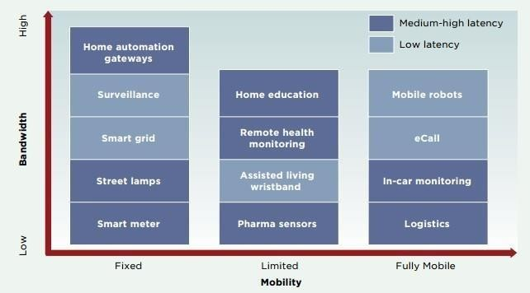Mechanisms for remotely managing such devices and applications could allow intelligent scheduling, which would facilitate an appropriate application development and reduce the vulnerability of the network to application misbehavior.

### Fig-3.1.2: Applications of Internet of Things

The Internet of Things promises to deliver a step change in individuals’ quality of life and enterprises’ productivity. Through a widely distributed, locally intelligent network of smart devices, the IoT has the potential to enable extensions and enhancements to fundamental services in transportation, logistics, security, utilities, education, healthcare and other areas, while providing a new ecosystem for application development.

## SYSTEM ARCHITECTURE DIAGRAM

Architecture diagram is displayed in the figure 3.2

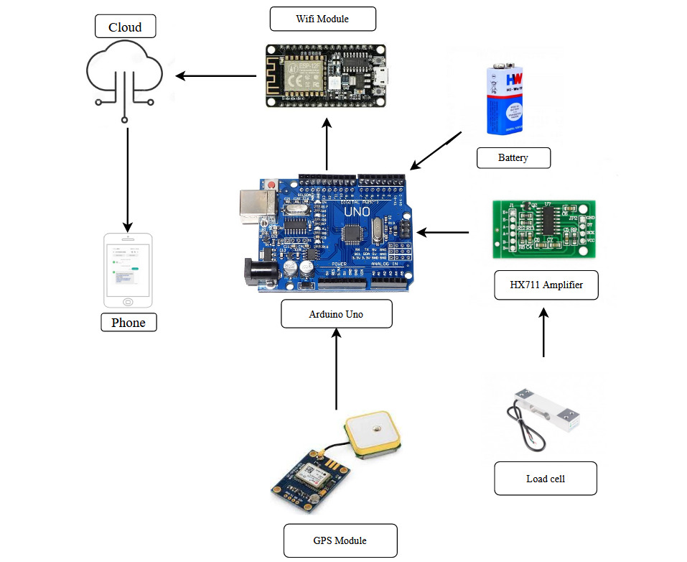

**Figure 3.2(a) Architecture Diagram**

The block diagrams provide the conceptual idea of how each block are interrelated to the whole task. It defines the basic link of various blocks with each other while the hardware specification will detail out the components involved in this design process.

Software portion is mainly focused in the platform and its interface with number of sensor where the flow of the system operation will be detailed out elaborately. Since the system is mainly in automation, accuracy is focused more.

1

.

### Node MCU Microcontroller:

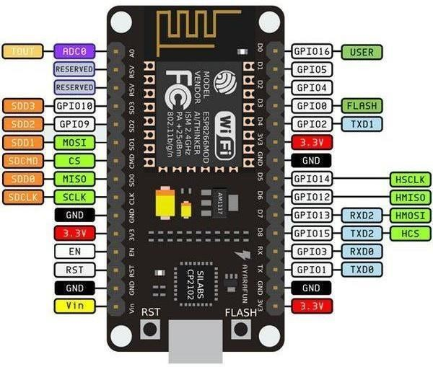Node MCU is a low-cost open source IoT platform. It initially included firmware which runs on the ESP8266 Wi-Fi SoC from Espress if Systems, and hardware which was based on the ESP-12 module. Later, support for the ESP32 32-bit MCU was added.

### Fig-3.2.1: Node MCU Microcontroller

#### Specification:

* + - * Voltage:3.3V.
      * Wi-Fi Direct (P2P), soft-AP.
      * Current consumption: 10uA~170mA.
      * Flash memory attachable: 16MB max (512K nor mal).
      * Integrated TCP/IP protocol stack.
      * Processor: Tensilica L106 32-bit.
      * Processor speed: 80~160MHz.
      * RAM: 32K + 80K.
      * GPIOs: 17 (multiplexed with other functions).
      * Analog to Digital: 1 input with 1024 step resolution.
      * +19.5dBm output power in 802.11b mode
      * 802.11 support: b/g/n.
      * Maximum concurrent TCP connections: 5.

### GPS Module

The Global Positioning System (GPS) is a space-based navigation system that provides location and time information in all weather conditions, anywhere on or near the Earth where there is an unobstructed line of sight to four or more GPS satellites. GPS is made up of three segments: Space, Control and User. The space segment is composed of 24 to 32 satellites in Medium Earth Orbit and also includes the boosters required to launch them into orbit.

The Control segment is composed of a Master Control Station, an Alternate Master Control Station, and a host of dedicated and shared Ground Antennas and Monitor Stations. The User Segment is composed of hundreds of thousands of U.S. and allied military users of the secure GPS precise positioning service, and tens of millions of civil, commercial and scientific users of the Standard Positioning Service. A GPS receiver calculates its position by precisely timing the signals sent by GPS [satellites](http://en.wikipedia.org/wiki/Satellites) high above the Earth.

Each satellite continually transmits messages that include the time the message was transmitted precise orbital information (the [ephemeris](http://en.wikipedia.org/wiki/Ephemeris)) the general system health and rough orbits of all GPS satellites (the almanac).

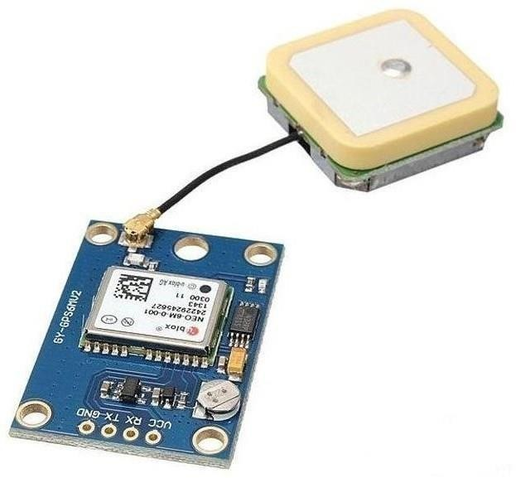.

### Fig-3.2.2(a) : GPS Module

The receiver uses the messages it receives to determine the transit time of each message and computes the distance to each satellite. These distances along with the satellites' locations are used with the possible aid of [trilateration,](http://en.wikipedia.org/wiki/Trilateration) depending on which algorithm is used, to compute theposition of the receiver. This position is then displayed, perhaps with a moving map display or latitude and longitude; elevation information may be included. Many GPS units show derived information such as direction and speed, calculated from position changes.

Three satellites might seem enough to solve for position since space has three dimensions and a position near the Earth's surface can be assumed. However, even a very small clock error multiplied by the very large [speed of light[35]](http://en.wikipedia.org/wiki/Speed_of_light) — the speed at which satellite signals propagate — results in a large positional error. Therefore receivers use four or more satellites to solve for the receiver's location and time. The very accurately computed time is effectively hidden by most GPS applications, which use only the location. A few specialized GPS applications do however use the time; these include [time](http://en.wikipedia.org/wiki/Time_transfer) [transfer,](http://en.wikipedia.org/wiki/Time_transfer) traffic signal timing, and [synchronization of cell phone](http://en.wikipedia.org/wiki/IS-95#Physical_layer) [base stations.](http://en.wikipedia.org/wiki/IS-95#Physical_layer)

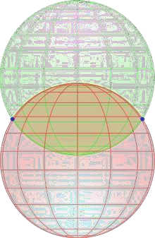Although four satellites are required for normal operation, fewer apply in special cases. If one variable is already known, a receiver can determine its position using only three satellites. For example, a ship or aircraft may have known elevation. Some GPS receivers may use additional clues or assumptions (such as reusing the last known altitude, [dead reckoning](http://en.wikipedia.org/wiki/Dead_reckoning), [inertial navigation,](http://en.wikipedia.org/wiki/Inertial_navigation_system) or including information from the vehicle computer) to give a less accurate (degraded) position when fewer than four satellites are visible.

### http://upload.wikimedia.org/wikipedia/commons/thumb/2/24/Circle_sphere_2-colour.svg/220px-Circle_sphere_2-colour.svg.pngFig-3.2.2(b): Two sphere surfaces intersecting in a circle

#### Fig-3.2.2(c) : Position calculation

GPS satellites broadcast signals from the space that GPS receivers use to provide three dimensional location plus precise time. GPS has become a mainstay of transportation systems worldwide, providing navigation for aviation, ground, and maritime operations. Disasters relief and emergency service depend upon GPS for location and timing capabilities intheir life-saving missions.

The accurate timing that GPS provides facilitates everyday activities such as banking, mobile phone operations, and even the control of power grids. Farmers, Surveyors, geologists and countless others perform their work more efficiently, safely, economically, and accurately using the free and open GPS signals. U-blox NEO-6M onboard

#### GPS: Features:

* U-blox NEO-6M onboard, with high-gain active antenna.
* IPX interface, for connecting different active antennas.
* Chargeable backup battery, keeps the ephemeris data when power down, supports hot starts.
* Onboard EEPROM for storing configuration information.

#### Specifications:

* TTL level, compatible with 3.3V/5V systems.
* Default baud rate 9600, configurable via u-center. 16

#### Applications:

* GPS Navigator.
* Quad copter Navigator.
* Positioning. How to Use:
* In the case of working with a MCU.
* VCC: connects to 3.3V/5V.
* GND: connects to GND.
* TXD: connects to MCU.RX.
* 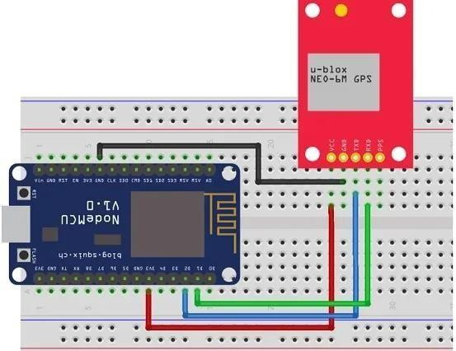RXD: connects to MCU.TX.

### Fig-3.2.2(d): GPS interfacing with microcontroller

### ARDUNIO UNO :

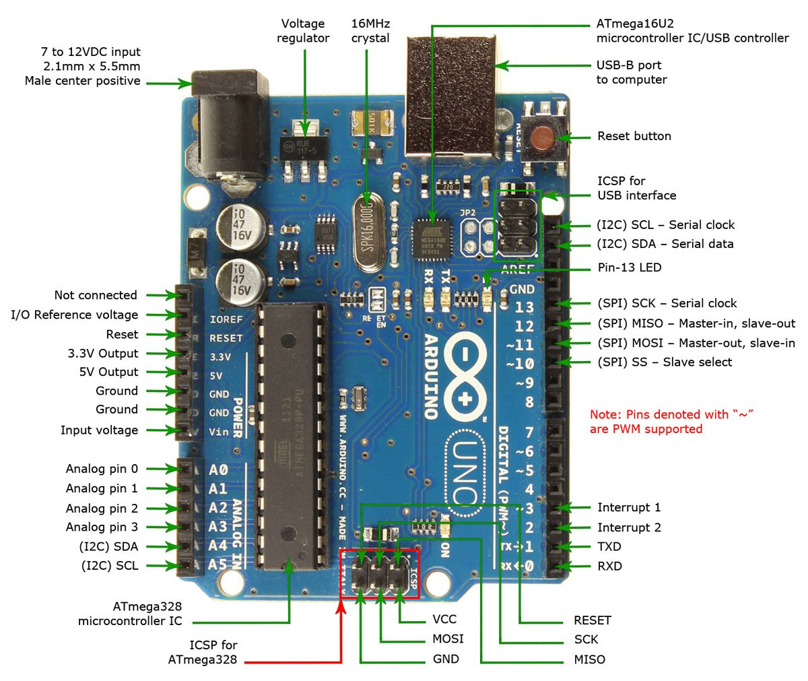

The Arduino Uno is an open-source microcontroller board based on the Microchip ATmega328P microcontroller and developed by Arduino.cc and initially released in 2010.[2][3] The board is equipped with sets of digital and analog input/output (I/O) pins that may be interfaced to various expansion boards (shields) and other circuits.[1] The board has 14 digital I/O pins (six capable of PWM output), 6 analog I/O pins, and is programmable with the Arduino IDE (Integrated Development Environment), via a type B USB cable.[4] It can be powered by the USB cable or by an external 9-volt battery, though it accepts voltages between 7 and 20 volts. It is similar to the Arduino Nano and Leonardo.[5][6] The hardware reference design is distributed under a Creative Commons Attribution Share-Alike 2.5 license and is available on the Arduino website.

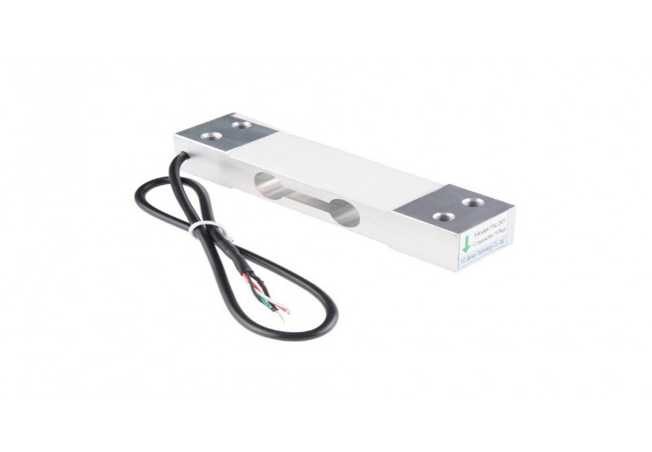**LOAD CELL :**

A load cell converts a force such as tension, compression, pressure, or torque into an electrical signal that can be measured and standardized. It is a force transducer. As the force applied to the load cell increases, the electrical signal changes proportionally. The most common types of load cell are pneumatic, hydraulic, and strain gauges

load cells are the kind most often found in industrial settings. It is ideal as it is highly accurate, versatile, and cost-effective. Structurally, a load cell has a metal body to which strain gauges have been secured. The body is usually made of aluminum, alloy steel, or stainless steel which makes it very sturdy but also minimally elastic. This elasticity gives rise to the term "spring element", referring to the body of the load cell. When force is exerted on the load cell, the spring element is slightly deformed, and unless overloaded, always returns to its original shape. As the spring element deforms, the strain gauges also change shape. The resulting alteration to the resistance in the strain gauges can be measured as voltage. The change in voltage is proportional to the amount of force applied to the cell, thus the amount of force can be calculated from the load cell's output.

**HX711 AMPLIFIER BOARD :**

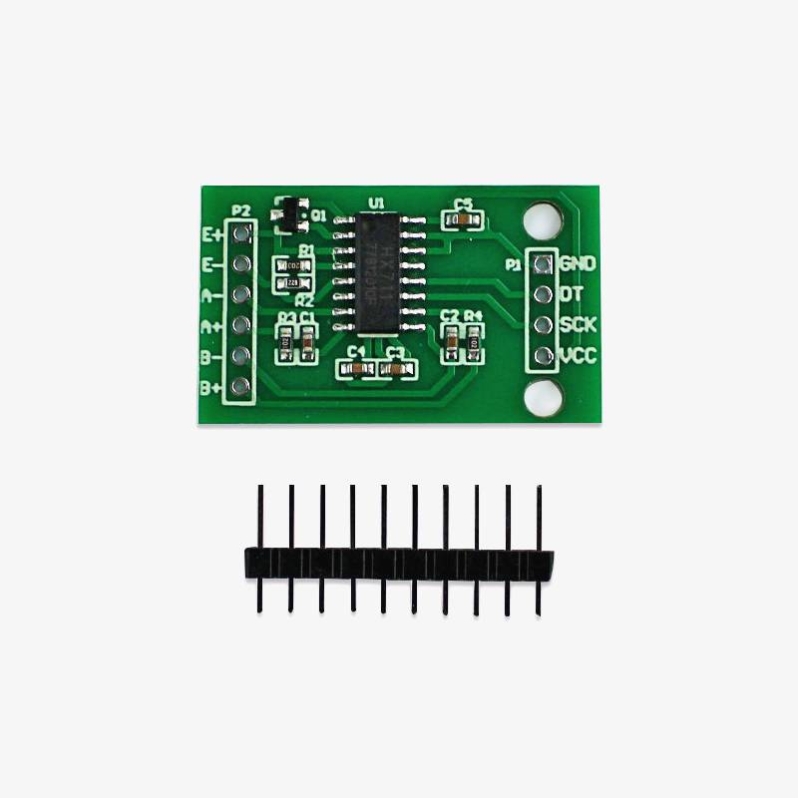

HX711 module is a Load Cell Amplifier breakout board for the HX711 IC that allows you to easily read load cells to measure weight. This module uses 24 high precision A/D converter chip HX711. It is a specially designed for the high precision electronic scale design, with two analog input channel, the internal integration of 128 times the programmable gain amplifier. The input circuit can be configured to provide a bridge type pressure bridge (such as pressure, weighing sensor mode), is of high precision, low cost is an ideal sampling front-end module.

HX711 is an IC that allows you to easily integrate load cell into your project. No need of any amplifiers or dual power supply just use this board and you can easily interface it to any micro-controller to measure weight.

The HX711 uses a two wire interface (Clock and Data) for communication. Compared with other chips, HX711 has added advantages such as high integration, fast response, immunity, and other features improving the total performance and reliability. Finally it's one among the best choices for electronic enthusiasts. The chip lowers the cost of the electronic scale,at the same time,improving performance and reliability.

### SOFTWARE IMPLEMENTATION

* 1. **ARDUNIO UNO on the Arduino Desktop IDE**

If you want to program your Ardunio uno while offline you need to install the [Arduino Desktop IDE](https://www.arduino.cc/en/Main/Software). The ardunio uno is programmed using the Arduino Software (IDE), our Integrated Development Environment common to all our boards. Before you can move on, you must have installed the Arduino Software (IDE) on your PC, as explained in the home page of our [Getting Started.](https://www.arduino.cc/en/Guide/HomePage) Connect your board with an USB cable; sometimes this cable is called a USBprinter cable.

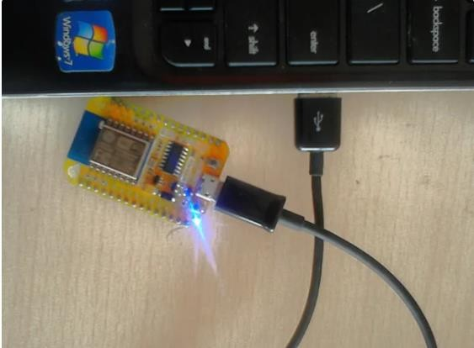The USB connection with the PC is necessary to program the board and not just to power it up. The board automatically draw power from either the USB or an external power supply. Connect the board to your computer using the USB cable. The green power LED (labelled PWR) should go on.

### Figure 4.1: Connecting Node MCU to PC

### Install the board drivers

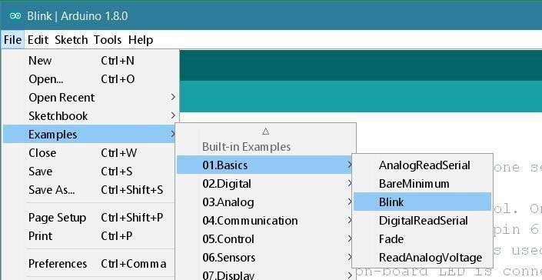If you used the Installer, Windows - from XP up to 10 - will install drivers automatically as soon as you connect your board. If you downloaded and expanded the Zip package or, for some reason, the board wasn't properly recognized, please follow the procedure below.

### Figure 4.2: Select the board driver

Click on the Start Menu, and open up the Control Panel. While in the Control Panel, navigate toSystem and Security. Next, click on System. Once the System window is up, open the Device Manager. Look under Ports (COM & LPT). You should see an open port named "Arduino UNO (COMxx)". If there is no COM & LPT section, look under "Other Devices" for "Unknown Device". Right click on the "Arduino UNO (COmxx)" port and choose the "Update Driver Software" option. Next, choose the "Browse my computer for Driver software" option. Finally, navigate to and select the driver file named "arduino.inf", located in the "Drivers" folder of the Arduino Software download (not the "FTDI USB Drivers" sub-directory). If you are using an old version of the IDE (1.0.3 or older), choose the Uno driver file named "Arduino UNO.inf" Windows will finish up the driver installation from there. Open your first sketch and then open the LED blink example sketch: File > Examples >01.Basics > Blink.

### Select your board type ESP8266 Board package

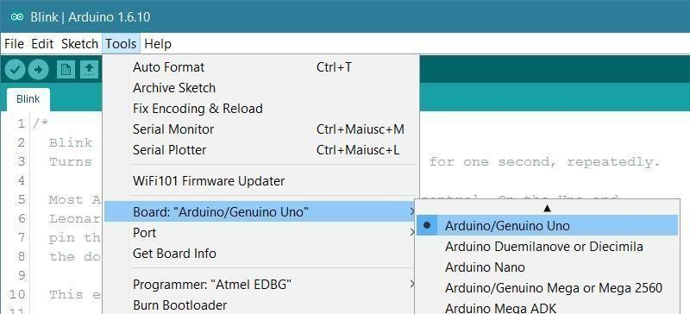Now open the tools in that select **Board: “Arduino/Genuino Uno”** and click on the **Boards Manager** as shown in the figure

### Figure 4.3(a): Select the type of board

#### Figure 4.3(b): Installing board package

### Select ESP8266 Arduino Board

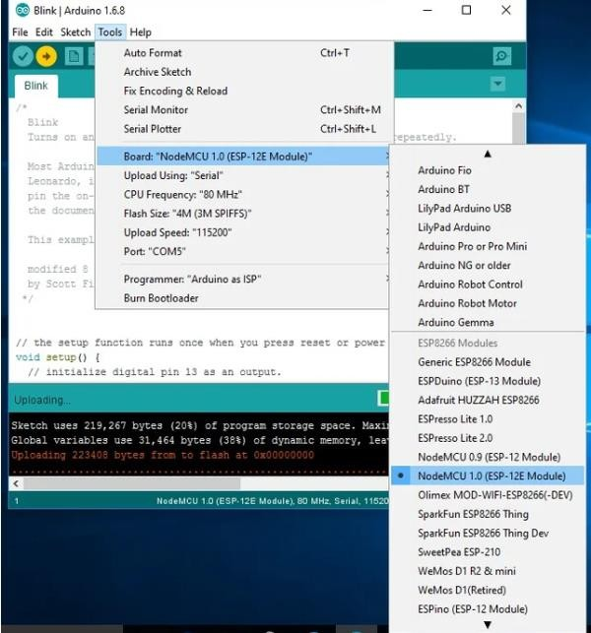To run the esp8266 with Arduino we have to select the **Board: “Arduino/Genuino Uno”** and then change it to **NodeMCU 1.0 (ESP-12E Module)** or other esp8266 modules depending on what you have .This can be done by scrolling down, as shown in the figure

#### Figure 4.4: Selecting ardunio uno

### Select COM Port

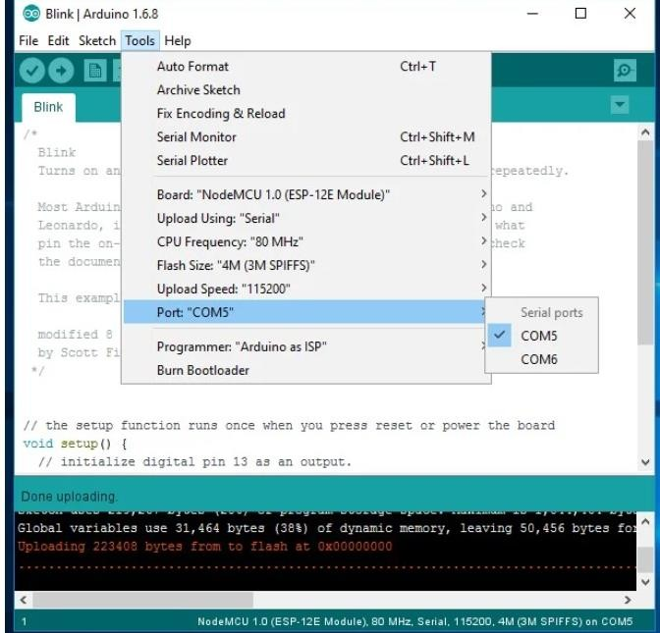The Blink example will open on a new window , click on tools to select the port: “COM” based on which esp8266 module is connected to your respected COM port of the computer. To select COM port refer previous steps.

**Figure 4.5: Selecting port**

### Uploading the program

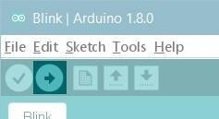Now, simply click the "Upload" button in the environment. Wait a few seconds - you should see the RX and TX leds on the board flashing. If the upload is successful, the message "Done uploading." will appear in the status bar.

### Figure 4.6(a): Sketch the program

**Figure 4.6(b): code snippets**

### Figure 4.6(c): code snippets

* 1. **Manage Libraries**

Libraries provide extra functionality for use in sketches, e.g. working with hardware or manipulating data. To use a library in a sketch, select it from the Sketch > Import Library menu. This will insert one or more #include statements at the top of the sketch and compile the library with your sketch. Because libraries are uploaded to the board with your sketch, they increase the amount of space it takes up. If a sketch no longer needs a library, simply delete its #include statements from the top of your code. There is a list of libraries in the reference. Then the Library Manager will open and you will find a list of libraries that are already installed or ready for installation. In this example we will install the Bridge library. Scroll the list to find it, click on it, then select the version of the library you want to install. Sometimes only one version of the library is available. If the version selection menu does not appear, don't worry: it is normal. Finally click on install and wait for the IDE to

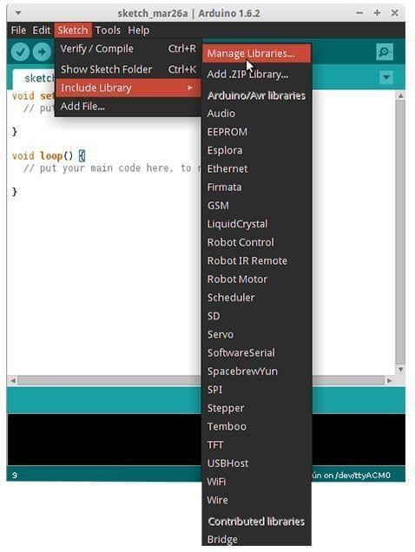install the new library. Downloading may take time depending on your connection speed. Once it has finished, an *Installed* tag should appear next to the Bridge library. You can close the library manager. Arduino libraries are managed in three different places: inside the IDE installation folder, inside the core folder and in the libraries folder inside your sketchbook.

#### Figure 4.7 Manage Libraries

# RESULTS AND OBSERVATIONS

#### Result Analysis

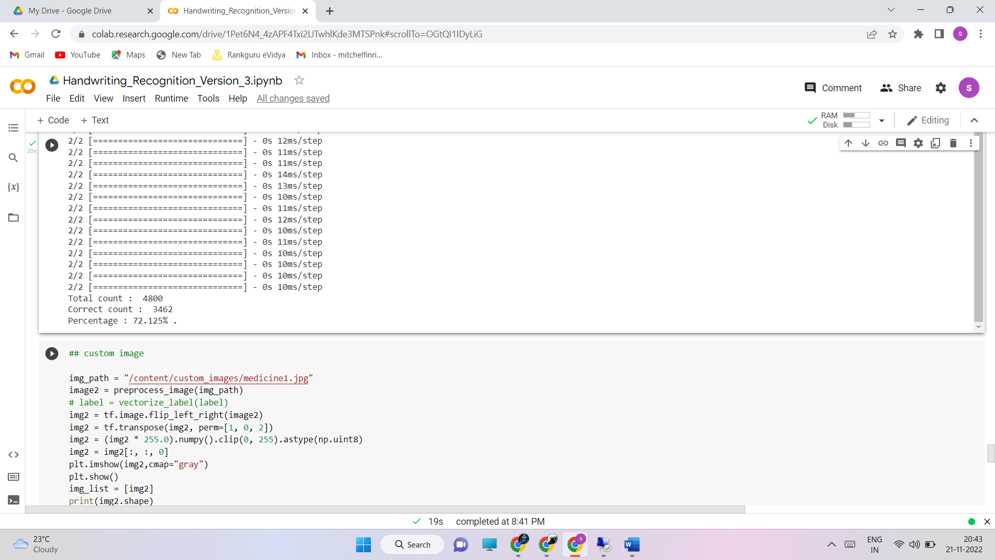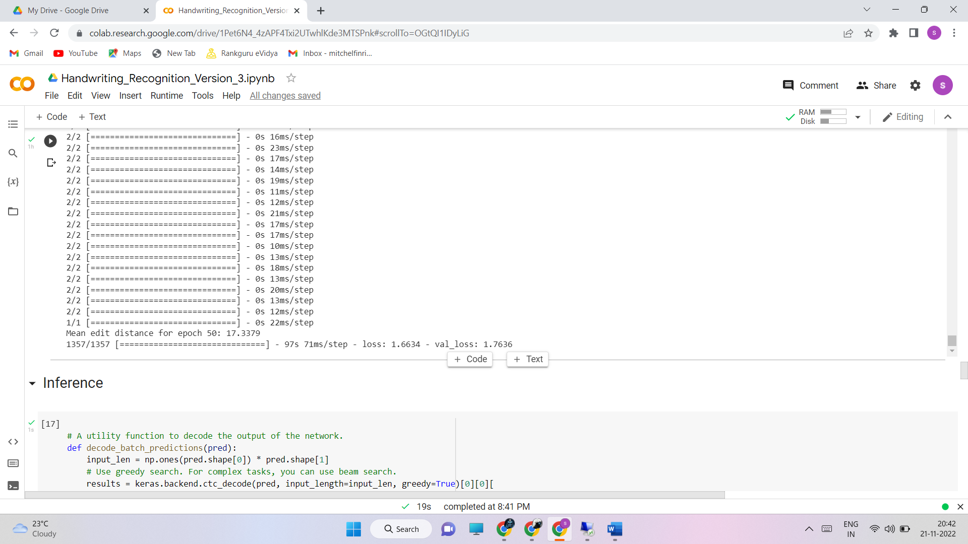

**90:5:5 with Epoch 50**

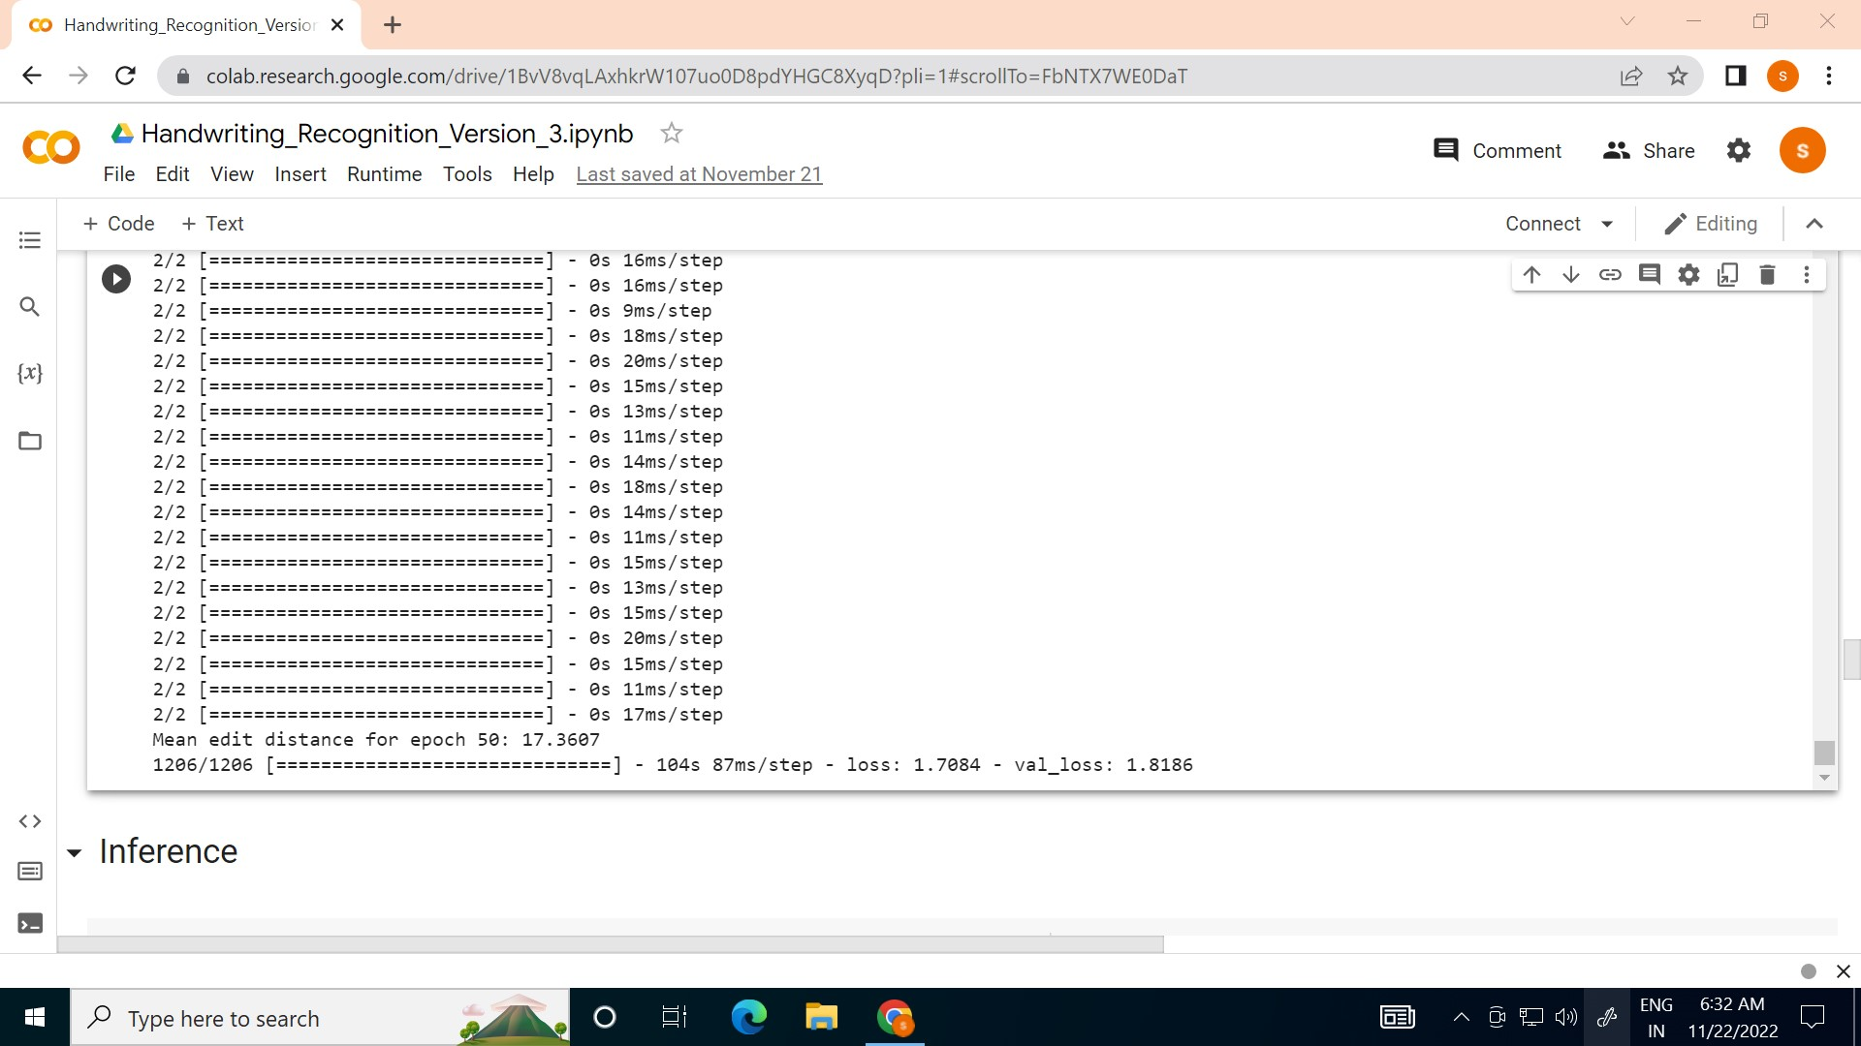

**80:10:10 with Epoch 50**

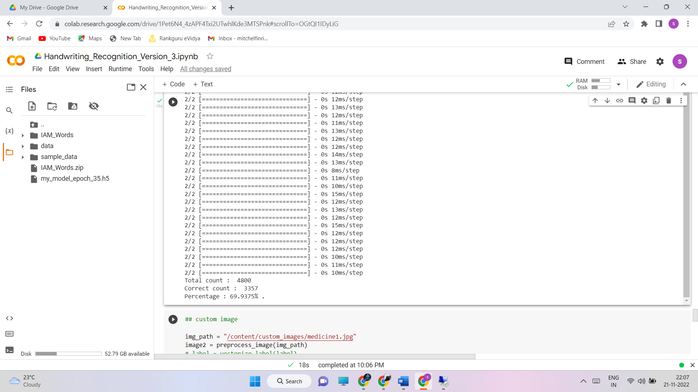

**70:15:15 with Epoch 50**

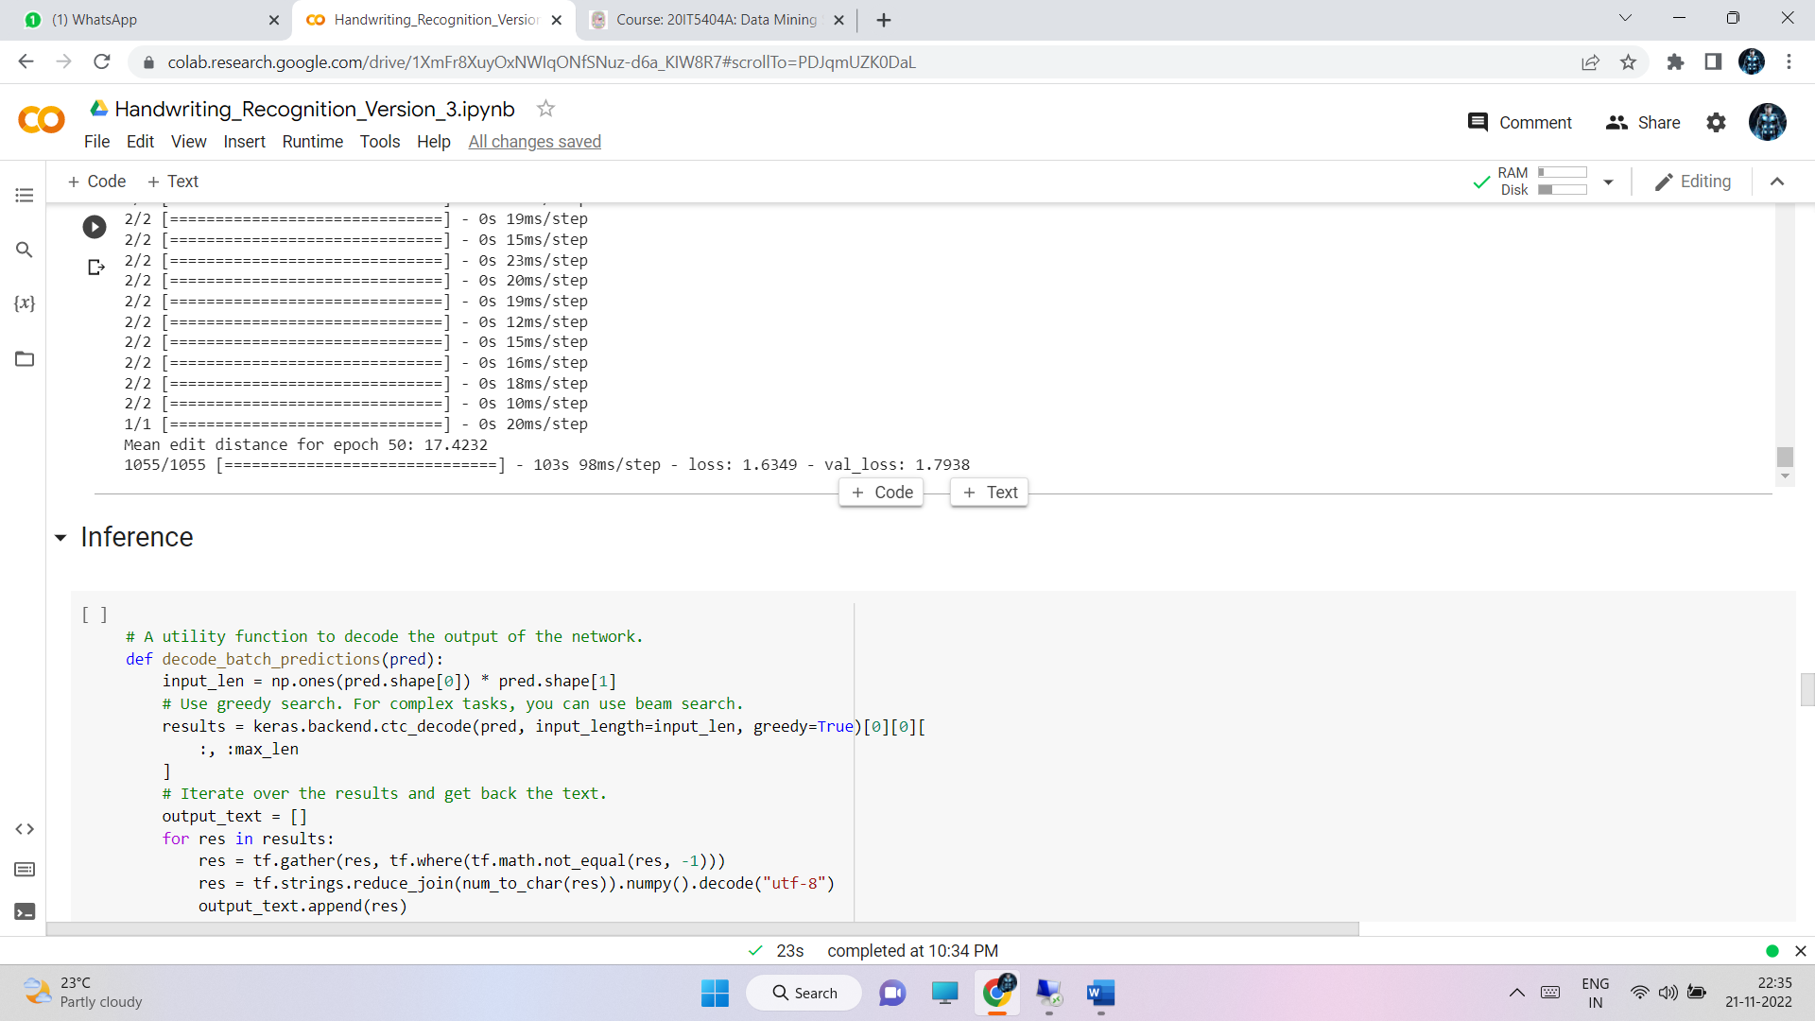

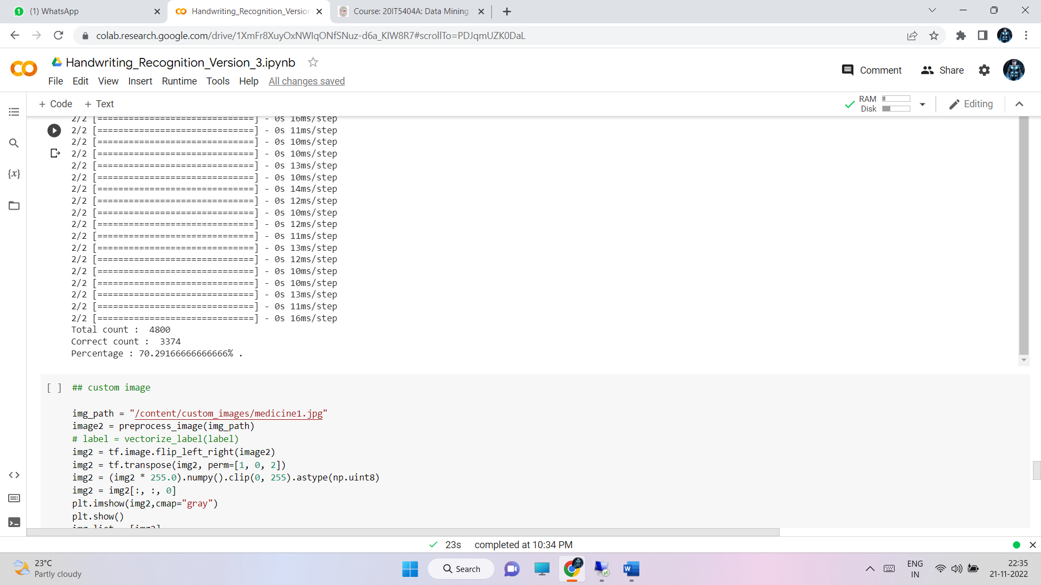

* 1. **CONCLUSION AND FUTURE STUDY**

Finally this model helps pharmacists and normal people to recognize the medicine name accurately in the doctor’s handwritten prescription .

The accuracy for this model can be further improved by training with more handwritten prescriptions.

Further an API can be created for this model which can be useful mobile applications and web application to use this model for recognizing text from prescription..

### References:

[1] Shaira Tabassum1, Ryo Takahashi1 , Md Mahmudur Rahman “Recognition of Doctors’ Cursive Handwritten Medical Words by using Bidirectional LSTM and SRP Data Augmentation”,IEEE | DOI: 10.1109/TEMSCON EUR52034.2021.9488622

[2] Tanvish Jain,Rohan Sharma,Ruchika Malhotra,” Handwriting Recognition for Medical Prescriptions using a CNN-Bi-LSTM Model” DOI: 10.1109/I2CT51068.2021.9418153

[3] Lovely Joy Fajardo1, Niño Joshua Sorillo , Jaycel Garlit , Cia Dennise Tomines , Mideth B. Abisado , Joseph Marvin R. Imperial , Ramon ,” Doctor’s Cursive Handwriting Recognition System Using Deep Learning” DOI:10.1109/HNICEM48295.2019.9073521

[4] L. J. Fajardo et al, "Doctor’s Cursive Handwriting Recognition System Using Deep Learning," 2019 IEEE 11th International Conference on Humanoid, Nanotechnology, Information Technology, Communication and Control, Environment, and Management ( HNICEM ), 2019, pp. 1-6, DOI: 10.1109/HNICEM48295.2019.9073521